Practical # 2
Design and implement a CI/CD pipeline using GitHub Actions that performs the complete deployment of the above system.
m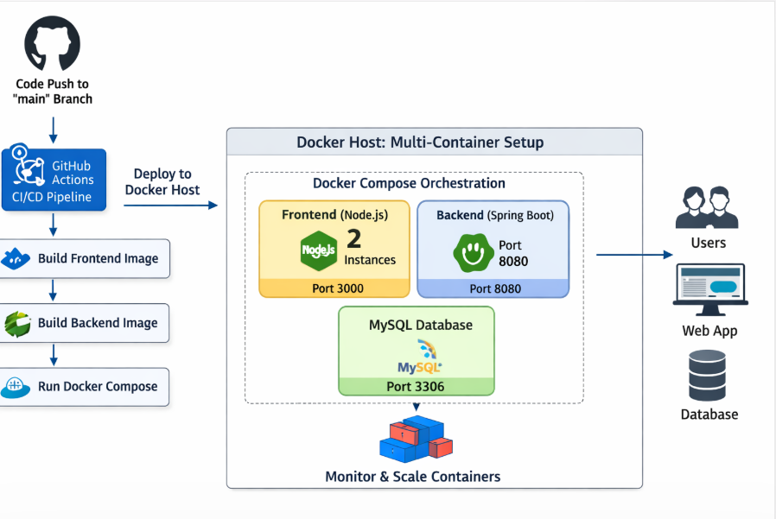

mnnmmnmnn

